A guide to promoting the toolkit across social media
This guide may be used to promote the Gambling Harms Women Too website and to raise awareness about the impact of gambling on women. In this guide are images, captions, and examples of post that could be made.
Images for social media posts
Please find below a selection of images that can be posted to social media. They have been developed in accordance with the best size requirements for each platform.
Linked In 1 | Linked In 2 | Linked In 3
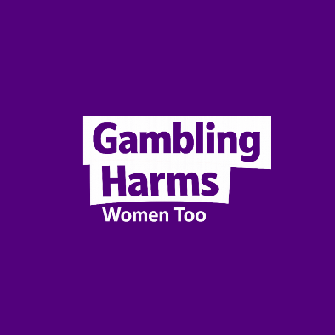 | 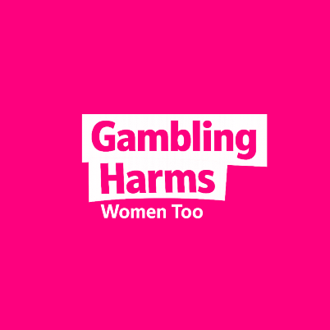 | 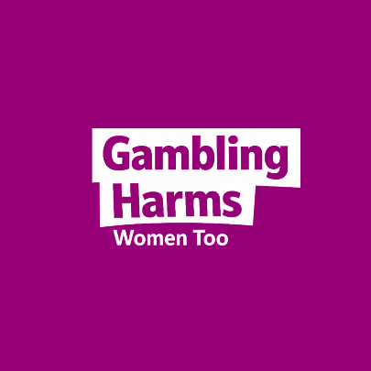
Linked In 4 | Linked In 5
 | 

Instagram 1 | Instagram 2 | Instagram 3
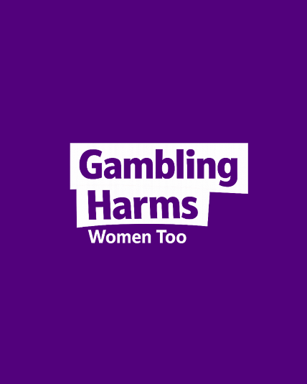 | 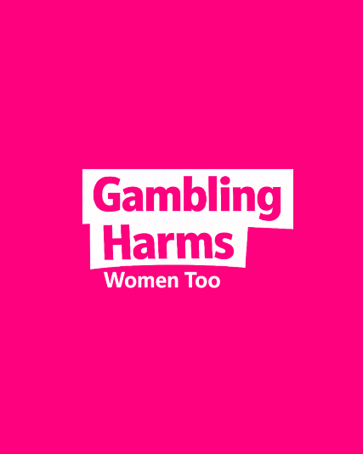 | 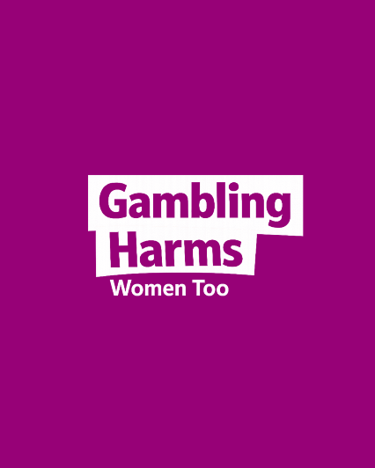
Instagram 4 | Instagram 5
 | 
Social media captions
Here are some examples of different captions that could be used in social media posts to promote the website and raise awareness about the impact of gambling on women.
Caption options for social media
Option 1 | Gambling harm affects women too.  Gambling has become a normal part of many women's social environments. When gambling is everywhere, the harms it causes can be harder to recognise.  Too often, women's experiences of gambling harm are overlooked.  To learn more, visit www.GamblingHarmsWomenToo.com
Option 2 | Gambling harm affects women too.  Women's experiences of gambling are often missing from public conversations about gambling harm.  The Gambling Harms Women Too toolkit brings together research, lived experience, practical resources, fact sheets, videos, and a podcast to help build understanding of how gambling affects women and what can be done to prevent harm.  Explore the resources and listen to the podcast series at www.GamblingHarmsWomenToo.com
Option 3 | Women's experiences of gambling harm have often been overlooked in research, policy, and public discussions.  The Gambling Harms Women Too toolkit draws on research conducted with women in the ACT and years of research with women across Australia to better understand how gambling has become normalised in women's lives and the impacts this can have.  Developed in collaboration with researchers from Deakin University and Curtin University, and the Gambling Harm Lived Experience Experts, the toolkit brings together research evidence and lived experience perspectives to support learning, discussion, and action.  Learn more at www.GamblingHarmsWomenToo.com

Examples:
Text | Example Image
Social media post:
Gambling harm affects women too.

Gambling has become a normal part of many women's social environments. When gambling is everywhere, the harms it causes can be harder to recognise.

Too often, women's experiences of gambling harm are overlooked.

To learn more, visit www.GamblingHarmsWomenToo.com
LinkedIn post:
Women's experiences of gambling harm have often been overlooked in research, policy, and public discussions.

The Gambling Harms Women Too toolkit draws on research conducted with women in the ACT and years of research with women across Australia to better understand how gambling has become normalised in women's lives and the impacts this can have.

Developed in collaboration with researchers from Deakin University and Curtin University, and the Gambling Harm Lived Experience Experts, the toolkit brings together research evidence and lived experience perspectives to support learning, discussion, and action.

Learn more at www.GamblingHarmsWomenToo.com

